**FLOOD MONITORNING AND EARLY WARNING**

**PROGRAM(python):**

ine BLYNK_TEMPLATE_NAME "IOT FLOOD MONITORING"

#define BLYNK_AUTH_TOKEN "gy2bzR-i-RbPW3oWOpAiDgr6sSVzIHVZ"

#define BLYNK_TEMPLATE_ID "TMPL3tobBFjj-"

#def

char auth[] = BLYNK_AUTH_TOKEN;

char ssid[] = "Wokwi-GUEST";

char pass[] = "";

#define BLYNK_PRINT **Serial**

#include <WiFi.h>

#include <WiFiClient.h>

#include <BlynkSimpleEsp32.h>

#include <ESP32Servo.h>

Servo gate;

const int trigPin=2;//d2

const int echoPin=4;//d4

const int servoPin = 18;//d18

long duration;

int distance;

void setup() {

**Serial**.begin(9600);

  Blynk.begin(auth, ssid, pass);

   pinMode(trigPin, OUTPUT);

   pinMode(echoPin, INPUT);

   gate.attach(servoPin, 500, 2400);

}

**Libraries.txt**

**#Wokwi Library List**

**# See** [**https://docs.wokwi.com/guides/libraries**](https://docs.wokwi.com/guides/libraries)

**Blynk**

**DHT12 sensor library**

**DHT sensor library**

**Serve**

**ESP32Servo**

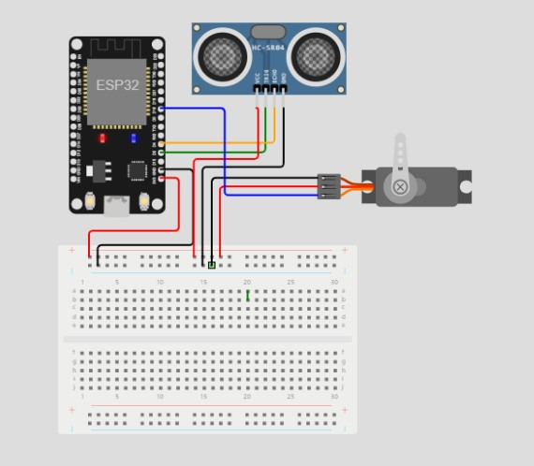

**OUTPUT:**

